Untainted
Unknown to them are the wonders and dangers of the magic of the world
Adventures: Untainted rarely adventure. They are often content with being general labor or farm hands. Those that do adventure do so to either use magic vicariously through their allies, or to show the weakness the world suffers from magic.

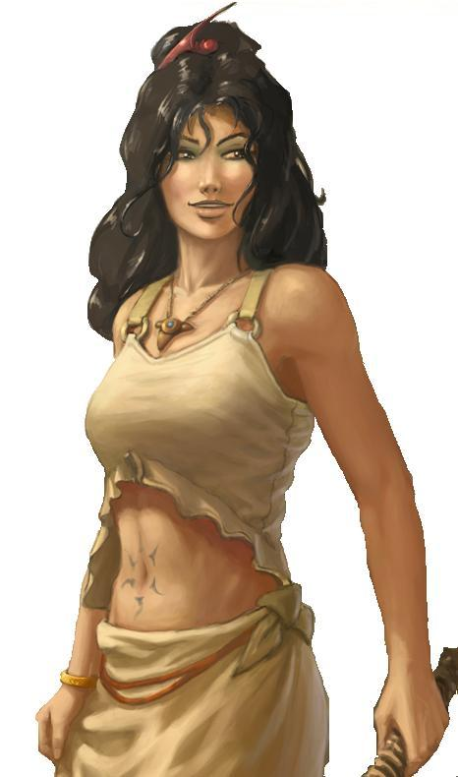
Characteristics: Untainted often play the role of a rouge as they have a high skill set, but not to uncommon they can find themselves in the heat of battle much like a monk, barbarian or fighter. The Untainted are unaffected by any magic ever. Magic weapons in their hands are nothing more than well crafted steel, magic amulets/rings/armor worn by Untainted are nothing more than the materials they are made from. But on the other hand a magic fireball exploding around an Untainted is nothing more than hot air. A magically sealed door opens with ease for an Untainted. An illusionist is nothing more than a fraud to an Untainted. While some can choose to completely swear off magic and become Untainted, more often are those without the knowledge of magic and chosen by the fates to become Untainted.

Alignment: Untainted are most often true neutral, they do not favor good nor evil, and tend to stay out of the extremes of law and chaos. If they follow laws it is because they choose to do so not because someone enforces them, but if they choose to break laws it was also because it was something that was what he wanted. More often will an Untainted be good and lawful, only for the reason that they would not mettle and disturb the flow of life.

Religion: Untainted do not worship gods. Those that are unaware of magic do not know their influence and those who wish to become Untainted must swear off all allegiances with any god. They do accept the existence of gods. Some may choose to agree with or even view some gods as role models, but they do not accept their help in any way.

Background: Untainted are extremely rare, they often are lost to the world completely as they live menial lives and no one knows of their gifts. Training to become Untainted is even more rare as the everyday life of any normal person is filled with the conveniences of magic, and swearing off such magics are amazingly difficult. Those that succeed to truly become Untainted are often driven mad by the new realization of life they have bestowed upon themselves.

Races: Untainted can appear in any race. Less common are those who are racially infused with magic such as gnomes and elves, however they still do happen. When they do happen in these societies they are often shunned and cast out from society. Half orcs and Halflings have the most common appearances of Untainted. And Humans and Dwarfs often find Untainted in their commoners. Of those who wish to become Untainted Half elves are usually the prime race that chooses this path as they are often shunned by both parents’ societies and cast out as loners. They often have the easiest time as they can use this shame to feed their goal towards becoming Untainted.

Other Classes: Untainted often get along well with monks, barbarians, and Fighters as their use of magic tends towards their items. They can get along with base class rouges as they use their cunning to get around in the world, but a rouges love for the mysterious often turns an Untainted off to them. Untainted dislike Clerics and Druids, but can understand their need and use of the divine, but view it as a weakness of character rather than strength. Finally Untainted completely refuse to associate with wizards and sorcerers as their indulgence in the arcane make them weeks in an Untainted's eyes.

Role: An Untainted is often used as a substitute as a rouge, as their ability to see through magical traps and disguises is invaluable to a party who is missing such an asset. Untainted with high Strength and or Dexterity scores can be valuable combatants as well but do not receive the bonuses of that of a fighter or ranger.

GAME RULE INFORMATION

Untainted have the following game statistics.

Abilities: Constitution is very important as it gives them the constant fortitude to survive life without the luxuries of magic. Dexterity and Strength are useful for those who wish to be combatants.

Alignment: Any.

Hit Die: d6.
Class Skills: Balance, Bluff, Climb, Craft, Decipher Script, Diplomacy, Disable Device, Disguise, Escape Artist, Gather Information, Handle Animal, Heal, Hide, Intimidate, Jump, Listen, Move Silently, Open Lock, Ride, Search, Sense Motive, Sleight of Hand, Spot, Survival, Swim, Tumble, Use Rope
Skill Points at Each Level: (8 + Int Modifier) x 4, at 1st level
8 + Int Modifier
Class Features
All of the following are class features for the Untainted Class.

Weapon and Armor Proficiency: Untainted are proficient with all simple and all light and medium armor but not shields.

Untainted Resistance: An Untainted is resistant to all magic both positive and negative. An Untainted is treated as having spell resistance of 20 + Untainted level. The Untainted has no control over this ability and hence cannot drop his spell resistance at will. In addition an Untainted automatically attempts to resist all friendly spells.

Untainted Touch: Magic Items an Untainted come in contact with are treated as though they have entered an anti magic field, to include potions, scrolls, wands, and rods.

Battle Fortitude: An Untainted becomes familiar with battle and adapts to the stress from it. An Untainted receives a competence bonus of + 2 to Fortitude Saves and + 2 to Initiative rolls. An Untainted loses this if he is wearing a shield or heavy armor.

Bonus Feat: When an Untainted receives a bonus feat. This feat can be any feat that affects a skill of an Untainted skill, even if they don't meet the prerequisite for the feat.

Untainted Constitution: Class level number of times per day an Untainted can use his Constitution modifier in place of a skills ability.

Fast Healing: Due to an Untainted pure constitution they are able to heal faster than the normal person. An Untainted can activate fast healing +1, 2 times per 1/2 class level per day for 1 hour. This bonus increases to +2 at level 10, +3 at level 15, and +4 at level 19

True Sight: An Untainted gains True sight as per the spell. An Untainted is able to see everything as the world truly is regardless of what the magics of the world attempt to make the world would like to make you believe.

Trained Constitution: Because an Untainted is constantly using their constitution they gain an additional point in constitution permanently at 7th and 15th level. An Untainted gets this point even if it takes them above their racial max.

Magical Breakdown: An Untainted hones his ability to repel magic onto others. An Untainted can make a touch attack that does not provoke attacks of opportunity, if the Untainted succeeds the person touched is treated as though they were in an anti magic field for 1D4 rounds. If Magical Breakdown is used on a magical beast or anything with the sub-race “magical” this works as a finger of death spell where the dc is 10 + Untainted Constitution modifier +1/2 class level

Natural Armor: An Untainted becomes so callous from physical attacks he receives a +1 natural armor at 11th level and an addition +1 at 17th level.

Anti Magic Channeling: Anything an Untainted uses becomes a tool to spread his Magical Breakdown. 3 times per day, as a free action, an Untainted can imbue a weapon or his armor with Magical Breakdown, anyone who successfully attacks or is successfully struck by an Untainted must make a Will Save vs. 10 + Untainted’s Constitution modifier + Untainted’s level

Evasion: Realizing that he is still vulnerable to some magic an Untainted learns to get out of the way of things that would potentially hurt him

Improved Evasion: At level 18 an Untainted Improves on his Evasion.

Magic Destruction: Three times per day an Untainted can use his Magical Breakdown to permanently destroy a magical item of his choice visually worn or carried by the target of the Magical Breakdown (does not apply to items in the opponents bags).

Table: Untainted
Level | BAB | Fort  Save | Ref  Save | Will  Save | Special
1st | +0 | 2 | 0 | 0 | Untainted Touch, Untainted Resistance
2nd | +1 | 3 | 0 | 0 | Battle Fortitude
3rd | +2 | 3 | 1 | 1 | Untainted Constitution
4th | +3 | 4 | 1 | 1 | Bonus Feat
5th | +3 | 4 | 1 | 1 | Fast Healing +1
6th | +4 | 5 | 2 | 2 | True Sight
7th | +5 | 5 | 2 | 2 | Trained Constitution
8th | +6/1 | 6 | 2 | 2 | Bonus Feat
9th | +6/1 | 6 | 3 | 3 | Magical Breakdown
10th | +7/2 | 7 | 3 | 3 | Fast Healing +2
11th | +8/3 | 7 | 3 | 3 | Natural Armor +1
12th | +9/4 | 8 | 4 | 4 | Bonus Feat
13th | +9/4 | 8 | 4 | 4 | Anti magic channel
14th | +10/5 | 9 | 4 | 4 | Evasion
15th | +11/6/1 | 9 | 5 | 5 | Trained Constitution, Fast Healing +3
16th | +12/7/2 | 10 | 5 | 5 | Bonus Feat
17th | +12/7/2 | 10 | 5 | 5 | Natural Armor +2
18th | +13/8/3 | 11 | 6 | 6 | Improved Evasion
19th | +14/9/4 | 11 | 6 | 6 | Bonus Feat, Fast Healing +4
20th | +15/10/5 | 12 | 6 | 6 | Magical Destruction

